LESSON 7

**REPRODUCTIVE SYSTEMS**

**TODAY’S GOALS:**

Describe three functions of the male reproductive system.

Describe three functions of the female reproductive system.

Identify parts of the male and female reproductive systems.

Summarize the stages of the menstrual cycle.

Summarize the pathway of the sperm.

**National Standards:**

10.1.12 Evaluate factors that impact growth and development

during adulthood and late adulthood. (Relationships)

**MCj02906790000[1]**

INSTANT ACTIVITY

What are the FUNCTIONS of the MALE reproductive system

1. To produce sex hormones
2. To produce and store sperm
3. To deliver sperm to the female reproductive system

VOCABULARY

**MALE REPRODUCTIVE SYSTEM**

|  |  |
| --- | --- |
| **Penis** | External sexual organ through which sperm leave the body |
| **Scrotum** | Sac of skin carrying the testes |
| **Foreskin** | Loose skin covering the penis |
| **Vas Deferens** | Tube used to transfer sperm to the seminal vesicles. Sperm Highway |
| **Prostate Gland** | Adds fluid that protects the sperm |
| **Testes** | Male Reproductive Glands  2 major functions: Produce Testosterone and Produce Sperm. |
| **Seminal Vesicle** | Add a fluid that provides a source of energy for active sperm |
| **Urethra** | A tube that passes through the penis to the outside of the body |
| **Bulbo-Urethra Glands** | Produce fluid that protects sperm from acidic conditions in the urethra |
| **Ejaculation** | The ejection of semen from the penis |
| **Orgasm** | The sexual climax |
| **Nocturnal Emission** | An ejaculation during sleep; also called a wet dream. |
| **Masturbation** | The touching of one’s own genitals for sexual pleasure |

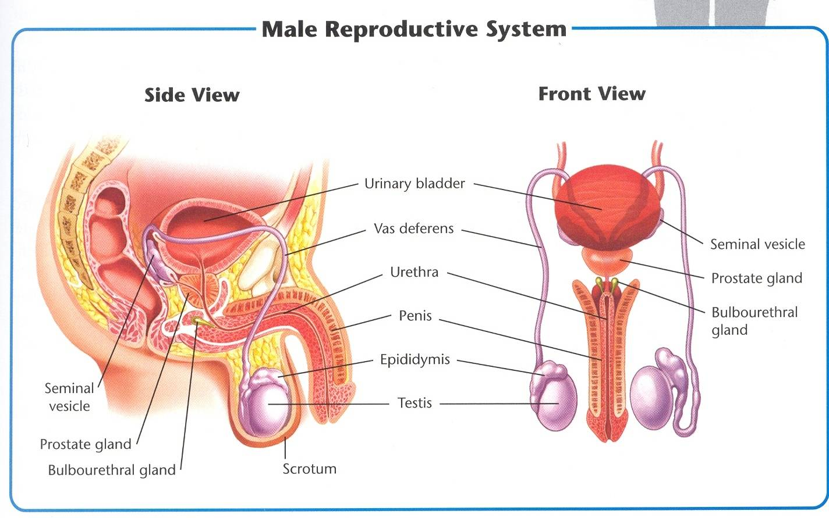

The Pathway of Sperm

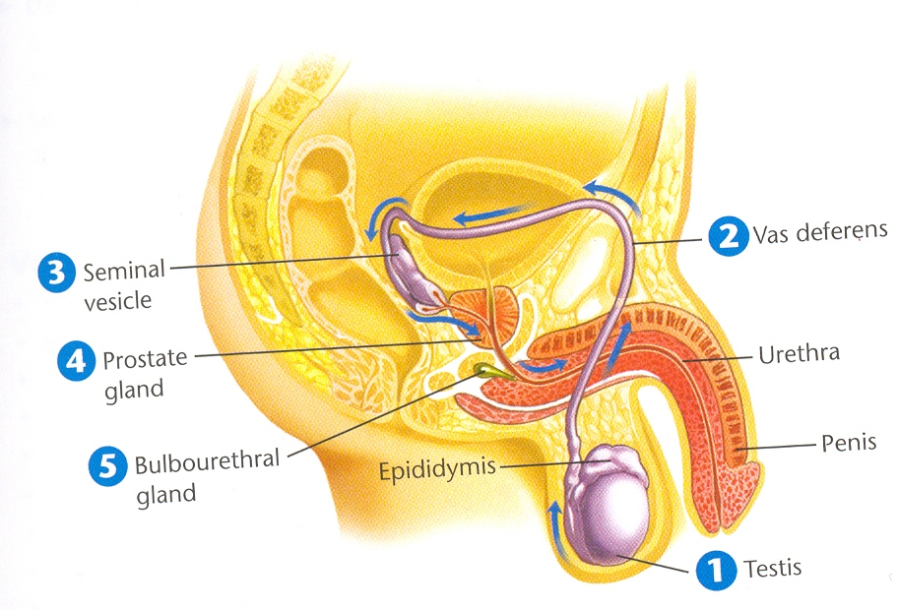

1. Sperm are produced in the TESTES. They mature and are stored in the epididymis.
2. Sperm travel through the vas deferens to the seminal vesicle.
3. Seminal vesicles add a fluid that provides a source of energy to the active sperm.
4. The prostate gland adds a fluid that protects the sperm.
5. The bulbourethral glands add a fluid that protects sperm from acidic conditions in the urethra.

Keeping Healthy

Caring for the male reproductive system involves the following:

|  |
| --- |
| **Cleanliness**  Showering can prevent fungal infections that cause jock itch |
| **Sexual Abstinence**  Many serious infections can result from sexual contact, practice sexual abstinence |
| **Protection from Trauma**  During athletic activities males should wear a cup  Tight clothes should be avoided (can cause irritation)  Be careful lifting heavy objects, can cause a hernia (intestines pushed into abdomen)  **Testicular Torsion: very serious**  Is a twisting of the testis and blood vessels cutting off blood supply  This is a medical emergency and must be untwisted in surgery within 6 hours  to keep testes alive |
| **Self-Exams**  Important to monitor their bodies for possible medical problems.  Painful urination, unusual discharge or sores require a medical exam  Examine for signs of **Testicular Cancer** (especially teens and young adults)  Testicular cancer is the most common type of cancers in males ages 15-34  Learn how to perform a self-exam |
| **Medical Checkups**  This is the time to bring up questions or ask out of curiosity  Men aged 50 are encouraged to get screened for **Prostate Cancer**  An enlarged prostate may cause painful or difficult urination  Infertility is a condition where you can reproduce |

VOCABULARY

**FEMALE REPRODUCTIVE SYSTEM**

|  |  |
| --- | --- |
| **Ovaries** | The female reproductive glands |
| **Fallopian Tubes** | The passageways that carry eggs from the ovaries to the uterus |
| **Uterus** | The hollow, muscular, pear-shaped organ in which a fertilized egg develops and grows. |
| **Cervix** | The narrow base of the uterus. |
| **Vagina** | The hollow, muscular passage leading from the uterus to the outside of the female body. |
| **Ova/Ovum** | The reproductive cells in females. Eggs. |
| **Menstrual Cycle** | The process during which an ovary releases a mature egg that travels to the uterus; if the egg is not fertilized, the uterine lining is shed and a new cycle begins. |

FUNCTIONS of the FEMALE reproductive system

1. Produce sex hormones
2. Mature eggs
3. Provide a nourishing environment in which a fertilized egg can develop into a fetus.

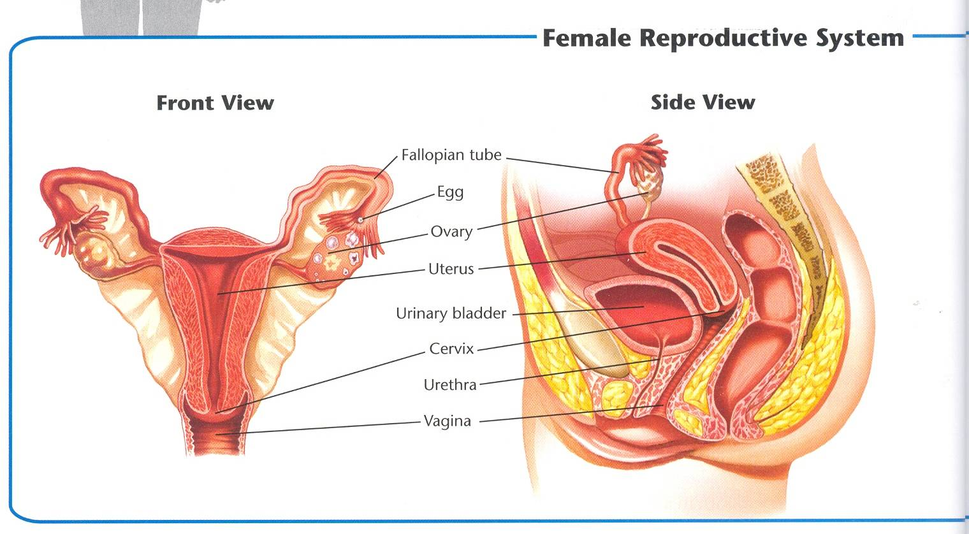

STAGES OF THE MENSTRUAL CYCLE

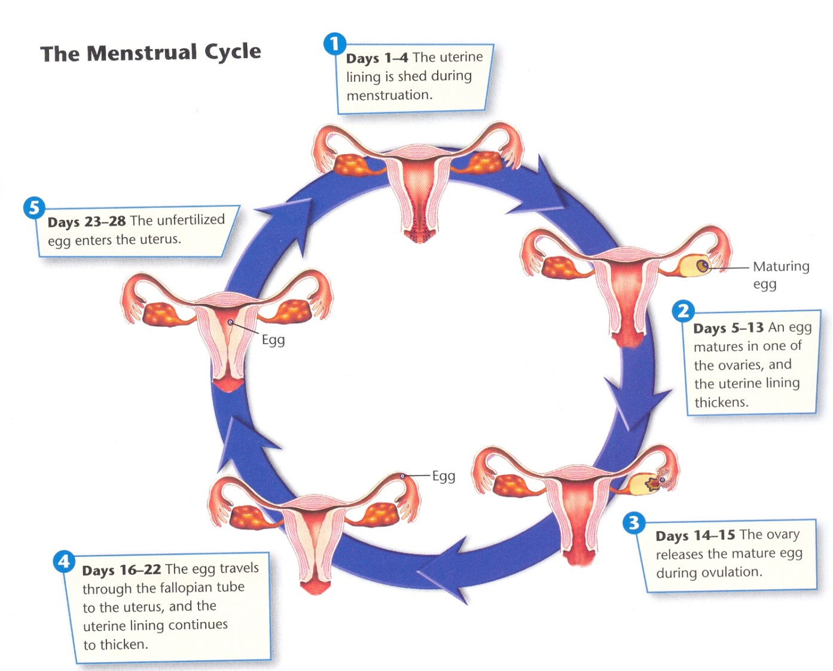

|  |  |
| --- | --- |
| **Days 1-4** | The uterine lining is shed during menstruation. |
| **Days 5-13** | An egg matures in one of the ovaries, and the uterine lining thickens |
| **Days 14-15** | The ovary releases a mature egg during ovulation. |
| **Days 16-22** | The egg travels through the fallopian tube to the uterus, and the uterine lining continues to thicken. |
| **Days 23-28** | The unfertilized egg enters the uterus. |

Keeping Healthy

Caring for the female reproductive system involves the following:

|  |
| --- |
| **Cleanliness**  Cleanliness is important during menstruation as well as daily cleansing  Hygiene sprays, douches and deodorant tampons are not necessary and could be harmful if they cover up signs of infection or cause irritation. |
| **Sexual Abstinence**  Many serious infections can result from sexual contact, practice sexual abstinence |
| **Proper Treatment for Infections**  Many women experience **vaginitis** an infection caused by yeast, bacteria or microorganisms. (discharge, odors, itching or burning sensation)  A common problem is also **cystitis** a bladder infection, untreated can lead to kidney infections |
| **Self-Exams**  Important to monitor their bodies for possible medical problems.  Symptoms of vaginitis, cystitis, sores or unusual pain see a Dr.  Call Dr. is heavier than normal bleeding or bleeding between periods  Learn how to perform a self-exam  Breast cancer is rare in teens but develop good habits early |
| **Medical Checkups**  Yearly checkups are recommended for all females who have reached puberty  Dr. will perform a Pap Smear during the pelvic exam to test for cervical cancer  Starting at age 40 Mammogram  Drs. Can also detect:  **Ovarian Cysts:** growths on the ovary  **Endometriosis**: the tissue from the lining of the uterus grows outside the uterus in the pelvic cavity. Very painful!!  **Infertility** is a condition where you can’t reproduce possibly due to a blocked fallopian tube(s) or problems with ovulation |

LESSON 8

**PREGNANCY**

**TODAY’S GOALS:**

Summarize the events that occur during the first week after fertilization.

Describe the structures that protect and nourish the embryo and fetus.

Identify four behaviors that are essential for a healthy pregnancy.

Explain the importance of prenatal care throughout pregnancy.

Describe the risks associated with teen pregnancy.

**National Standards:**

10.1.12 Evaluate factors that impact growth and development

during adulthood and late adulthood. (Relationships)

**MCj02906790000[1]**

INSTANT ACTIVITY

What are some factors you think a married couple should consider before they have a baby?

VOCABULARY

**PREGNANCY**

|  |  |
| --- | --- |
| Zygote | The united egg and sperm |
| Embryo | Time from the two-cell stage until nine weeks after fertilization. |
| Blastocyst | A hollow, spherical structure made up of about 50 to 100 cells that attaches to the uterus during implantation. |
| Implantation | Process from which the blastocyst attaches to the uterine wall. |
| Amniotic Sac | A fluid filled bag of thin tissue that develops to protect the developing baby. |
| Placenta | Structure that lines the wall of the uterus during pregnancy and nourishes the embryo or fetus with substances from the mother’s blood. |
| Umbilical Cord | The cordlike structure that connects the embryo of fetus to the placenta. |
| Fetus | The stage of human development from the third month after fertilization until birth. |
| Prenatal Care | Medical care received during pregnancy. |
| Obstetrician | A doctor who specializes in pregnancy and childbirth. |
| Trimester | One of the three periods that divides a pregnancy. Each trimester is approximately 3 months. |
| Ultrasound | High frequency sound waves used to create an image of a developing fetus. |
| Ectopic Pregnancy | Condition resulting from the implantation of the blastocyst in a location in the abdomen other than the uterus. |
| Miscarriage | The death of an embryo or fetus in the first 20 weeks of pregnancy. |

The Beginning of the Life Cycle

|  |  |
| --- | --- |
| **FERTILIZATION** | Of the hundreds of millions of sperm that enter the vagina during sexual intercourse, only a few hundred make it to the egg, and only one can fertilize it. Within seconds, the surface of the egg changes so that no more sperm can enter the egg. **In the first week after fertilization, the fertilized egg undergoes many cell divisions and travels to the uterus.** |
| **The Zygote** | Within 36 hours, while the zygote is traveling through the fallopian tube, it begins to divide. |
| **Cell Division** | The original cell divides to make two cells, becoming an embryo. As the embryo travels toward the uterus, its cells continue to divide. |
| **The Blastocyst** | About 5 days after fertilization, the embryo reaches the uterus, where it floats for a few days. |
| **Implantation** | Once the blastocyst forms, it begins to attach itself ti the wall of the uterus. |

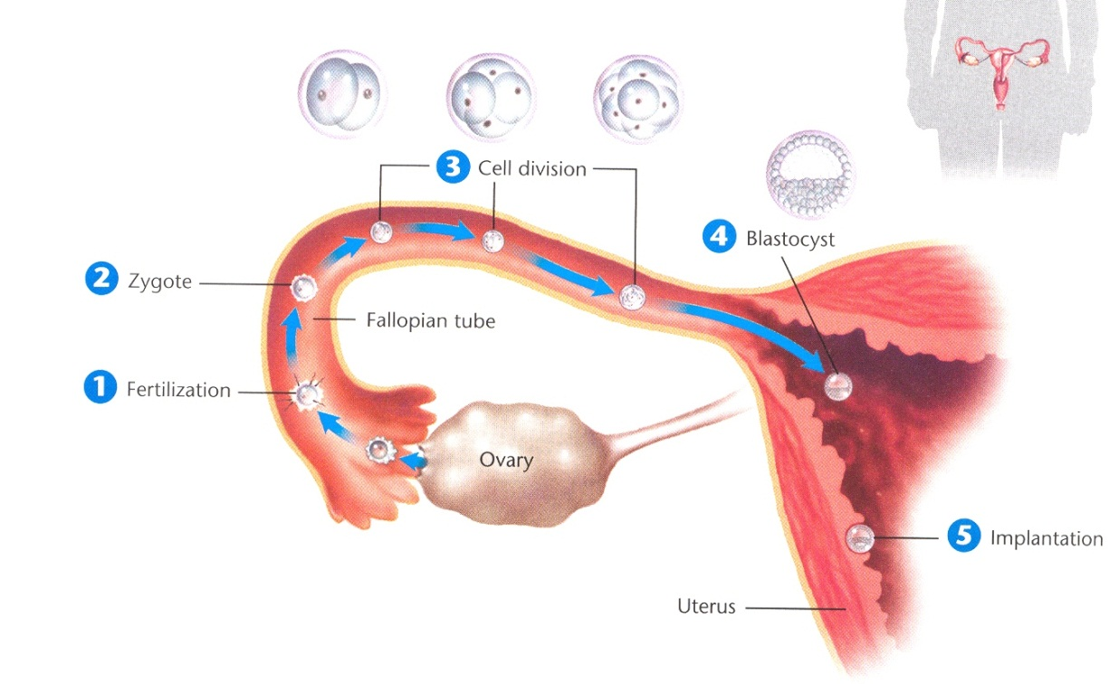

Development in the Uterus

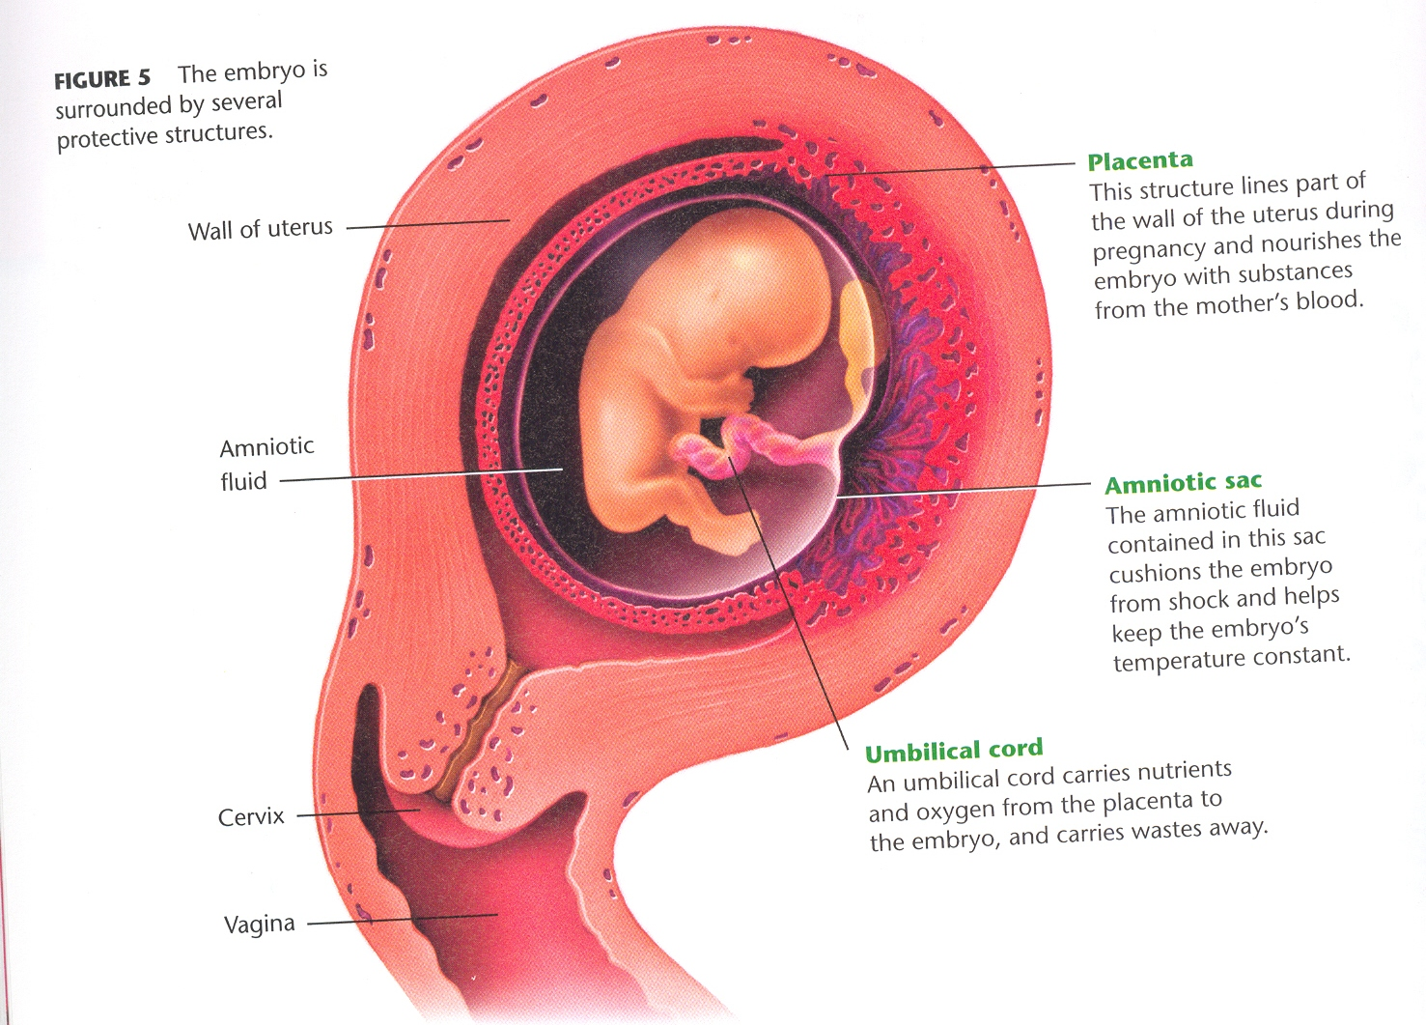

STAYING HEALTHY DURING PREGNANCY

**Getting proper nutrition and exercise and avoiding drugs and environmental hazards are especially important both before and throughout pregnancy.**

|  |  |
| --- | --- |
| **PROPER NUTRITION** | When you are eating for 2, a pregnant woman needs to eat more calories to support the growth of her own body AND the developing fetus.  Should be consuming about 300 extra calories per day.  Make sure your diet includes all the essential nutrients important for pregnancy, including FOLIC ACID. |
| **EXERCISE** | Regular physical activity is important for both the mom AND the baby. This can reduce the risk of gestational diabetes and other health problems. Always get a doctors approval on an exercise routine. |
| **AVOIDING ALCOHOL AND DRUGS** | These substances, even in very small amounts, can harm or potentially kill a developing baby, decrease a newborn’s chance to live, or cause lifelong problems.  Always consult a doctor before taking any medication, including pain medication or cold medication. |
| **AVOIDING ENVIRONMENTAL HAZZARDS** | Pregnant women should avoid the following:  X-rays: Both dental and skeletal.  Lead: Lead based paint can be harmful to the fetus.  Mercury: Most exposure to contaminated metal comes from eating contaminated fish. Women should avoid swordfish and shark entirely.  Cat Litter: Cat feces can contain a parasite that is especially dangerous to a developing fetus. |

PRENATAL CARE

The chances of having a healthy baby greatly increase when the mother is under the prenatal care of an obstetrician.

|  |  |  |
| --- | --- | --- |
| **FIRST TRIMESTER** | **SECOND TRIMESTER** | **THIRD TRIMESTER** |
| -Record medical history and weight.  -Note conditions that could affect the pregnancy.  -Prescribe prenatal vitamins as needed. | -Monitor heartbeat of fetus.  -Measure growth of uterus.  -Monitor complications using ultrasound and other tools. | -Check position and size of fetus.  -Check for warning signs of premature, or early birth.  -Continue to monitor for complications.  -Discuss birth process. |

COMPLICATIONS

|  |  |
| --- | --- |
| **Ectopic Pregnancy** | In very rare cases, the blastocyst implants in the fallopian tube or somewhere else in the abdomen. The embryo cannot develop normally and may put the mother’s life at risk. Surgery is necessary. |
| **Miscarriage** | The death of an embryo or fetus in the first 20 weeks of pregnancy. Usually occurs in the first trimester. |
| **Preeclampsia** | High blood pressure during pregnancy that prevents the fetus from receiving the necessary oxygen. Usually treated with bed rest. |
| **Gestational Diabetes** | Diabetes in a pregnant woman. Develops later in pregnancy and may cause the fetus to grow too large. |
| **Premature Birth** | Delivery of the baby before the 37th week. The earlier the birth, the greater the chance of problems. |

TEEN PREGNANCY

**Health Risks:** Teenagers face risks to their health and to the health of the fetus that most pregnant women in their 20’s and 30’s do not face.

1. Teenagers are still growing and maturing. A teen’s body may not be ready to support a developing baby.
2. Many pregnant teens do not follow diets that provide adequate nutrition for both the baby and their growing bodies.
3. Pregnant teens are less likely than adult women to seek early prenatal care.
4. Babies born to teenage mothers are more likely to suffer health problems

WRITING AND HEALTH

**In the space below, please describe how your life would be different if you had a baby. Consider how a baby would affect your free time, your friendships, your family relationships, and your goals for the future.**

_______________________________________________________________________________________________________________________________________________________________________________________________________________________________________________________________________________________________________________________________________________________________________________________________________________________________________________________________________________________________________________________________________________________________________________________________________________________________________________________________________________________________________________________________________________________________________________________________________________________________________________________________________________________________________________________________________________________________________________________________________________________________________________________________________________________________________________________________________________________________________________________________________________________________________________________________________________________________________________________________________________________________________________________________________________________________________________________________________________________________________________________________________________________________________________________________________________________________________________________________________________________________________________________________________________________________________________________________________________________________________________________________________________________________________________________________________________________________________________________________________________________________________________________________________________________________________________________________________________________________________________________________________________________________________________________________________________________________________________________________________________________________________________________________________________________________________________________________________________________________________________________________________________________________________________

LESSON 9

**PREVENTING PREGNANCY**

**TODAY’S GOALS:**

Explain why abstinence is the only completely effective way to prevent

pregnancy and STI’s.

Explain why contraception is a responsible decision for those who choose to

be sexually active.

Identify the three general types of contraception.

**National Standards:**

10.1.12 Evaluate factors that impact growth and development

during adulthood and late adulthood. (Relationships)

**MCj02906790000[1]**

VOCABULARY

|  |  |
| --- | --- |
| **Contraception** | The use of any accepted method to intentionally prevent pregnancy. (birth control) |
| **Effectiveness** | The likelihood that using a method of contraception will prevent pregnancy. |
| **Failure Rate** | The percentage of women who become pregnant using a particular contraception method during one year’s time. |
| **Spermicide** | A chemical agent that kills sperm. |
| **Sterilization** | The use of surgery or other procedure to make a person permanently incapable of reproduction. |

0

CONTRACEPTION METHODS

|  |  |  |  |  |
| --- | --- | --- | --- | --- |
| **Contraceptive**  **Methods** | **Failure Rate** | **Protection From STI’s** | **Availability** | **Proper Use** |
| Abstinence | 0% | Complete |  |  |
| Male Condom | 11% | Some | Over the Counter | Applied immediately before intercourse; used once. |
| Female Condom | 21% | Some | Over the Counter | Inserted before intercourse,  used once. |
| Diaphragm Plus  Spermicide | 17% | None | Prescription | Must be left in place for 6 hours after intercourse. Can be washed and re-used. |
| Cervical Cap Plus Spermicide | 17-23% | None | Prescription | Proper insertion can be difficult; must be left in place for 8 hours after intercourse. Can be washed and re-used. |
| Shield Plus Spermicide | 15% | None | Prescription | Must be left in place for 8 hours after intercourse. Can be washed and re-used. |
| Sponge | 16% | None | Over the Counter | Must be left in place for 6 hours after intercourse. Discarded after use. |
| Spermicide Alone | 35% | None | Over the Counter | Varies based on type. |
| Combination Pill  or Mini Pill | 1 to 2% | None | Prescription | Must be taken daily. |
| Patch | 1 to 2% | None | Prescription | New patch is applied once a week. |
| Ring | 1 to 2% | None | Prescription | New ring is inserted once a month. |
| Injection | <1% | None | Prescription | One injection every 3 months. |
| Permanent Methods | <1% | None | Prescription | One-time procedure.  Tubal Ligation- Female  Vasectomy- Male |

3 Types of Contraception

|  |  |  |
| --- | --- | --- |
| **Barrier Methods** | **Hormonal Methods** | **Permanent Methods** |
| Prevent sperm from reaching the egg. | Hormonal methods of contraception work by preventing ovulation or inhibiting fertilization. | Should only be used for people who are sure that they do not any children or do not want more children. |
| Male condom, female condom, diaphragm, cervical cap, shield, sponge, spermicides | Oral contraptions, the patch, the pill, rings, and injections | Vasectomy, tubal ligation, and sterilization implant. |

UNRELIABLE METHODS

|  |  |
| --- | --- |
| **Periodic Abstinence** | Abstaining from intercourse during the days of the female’s cycle where she is most likely to get pregnant. |
| **Withdrawal** | The removal of the penis from the vagina just before ejaculation. |

SCALE OF EFFECTIVENESS

**On the scale below, show the following contraception methods, comparing their total effectiveness against preventing pregnancy.**

Birth Control Pill Male Condom Sterilization Withdrawal

Diaphragm Female Condom Injections Abstinence

**100% 0%**

CONDOM CONNECTION

See if you can put the steps to placing a condom on correctly into the right order.

____Ejaculation occurs

____Apply more lubricant to the outside of the condom

____Carefully push the condom to one side

____Carefully open the condom by tearing the corner

____Make sure the right side of the condom is facing out

____Check the date

____Discard of the condom (do not flush it!)

____Move away from the vagina and remove the condom

____Apply Lubricant to the inside of the condom

_____The penis is fully erect

_____Carefully roll the condom down over the penis

____Pinch the tip and leave some room

____Ready to have intercourse

____Hold on to the base of the condom and carefully remove the penis from the

vagina

contraception

**Definition:** _________________________________________________  
 _________________________________________________

The act of refraining from sexual intercourse is called: ______________

**Barrier Methods Sponge Withdrawal**

**Hormonal Methods Birth Control Pill Cervical Cap**

**Permanent Methods Patch Vasectomy**

**Male Condom Ring Tubal Ligation**

**Female Condom Injection Diaphragm**

1. ___________________________________ of contraception prevent sperm from reaching the egg.

2. The ___________________________ is a barrier method that can only be obtained by seeing a healthcare professional.

3. An operation where the doctor makes a small incision in the scrotum and then severs each vas deferens is called a ___________________________________.

4. Hormonal Method where female hormones are released into the body through a ________________________________ taken daily.

5. The ___________________________ is a thin sheath that is usually made of latex that provides the best possible protection against STI’s.

6. _______________________________________ is a procedure where a woman’s fallopian tubes are cut or closed, blocking the sperm’s access to the released egg.

7. _______________________________ of contraception are only appropriate for people who are sure they either do not want children or do not want more children.

8. The ____________________________ is a hormonal method that prevents ovulation by releasing estrogen and progestin through the skin.

9. The __________________________ is a disc shaped, foam device that contains spermicide.

10. The _________________________________ is a thin plastic sheath that is inserted into the vagina and is also available over the counter.

11. A female may receive an _____________________________ of progestin every 3 months.

12. ________________________________ of contraception work by preventing ovulation or inhibiting fertilization.

13. The vaginal ______________________ is a flexible piece of plastic that contains hormones that are inserted into the woman’s vagina.

14. ___________________________ is one of the most ineffective methods of birth control because it does not protect against STI’s and has the highest failure rate.

15. The _________________________________ is smaller than the diaphragm, but does the same job.

LESSON 10

**SEXUALLY TRANSMITTED INFECTIONS**

**TODAY’S GOALS:**

Identify the best way to avoid sexually transmitted infections during the teen years.

Identify three of the most common STI’s including their symptoms and treatments.

List four other STI’s and describe their symptoms.

Know when a person should seek treatment for an STI.

**National Standards:**

10.1.12 Evaluate factors that impact growth and development

during adulthood and late adulthood. (Relationships)

**MCj02906790000[1]**

INSTANT ACTIVITY

1. What is this song about?
2. List two facts you learned from listening to this song.
3. List two behaviors the singer could have changed to avoid the situation.

STI QUIZ

|  |  |  |
| --- | --- | --- |
| 1 | A person can have an STI and not know it. | T |
| 2 | It is normal for women to have some vaginal discharge. | T |
| 3 | In this state, parents must be notified before minors can be tested or treated for an STI | F |
| 4 | Once you have had an STI and been cured, you cannot get it again. | F |
| 5 | It is easy to get syphilis or gonorrhea from a toilet seat. | F |
| 6 | It is possible to get crabs, scabies, or yeast infections from borrowed towels and clothing. | T |
| 7 | Women who have sex for the first time before age 20 are at higher risk for cancer of the cervix. | T |
| 8 | A pregnant woman who has an STI can pass the disease on to her baby. | T |
| 9 | STIs that aren’t cured early can make it impossible for a person to have children. | T |
| 10 | Most STIs go away on their own without treatment if people wait long enough. | F |
| 11 | Birth control pills offer excellent protection from STIs. | F |
| 12 | Condoms can help prevent the spread of STIs. | T |
| 13 | Burning with urination is a common symptom of STDs in both men and women. | T |
| 14 | AIDS can be passed from one person to another by hugging. | F |
| 15 | The symptoms of AIDS are the same as the symptoms of other sexually transmitted diseases. | F |

Risky Behviors and the STI Epidemic

The risky behaviors that account for the current STI epidemic include:

|  |
| --- |
| **Ignoring the Risks**  Do not take precautions  “It can’t happen to me”!!!! Yes it can!!! |
| **Having Multiple Partners**  The more sexual partners the greater chance of contracting and STI |
| **Not Seeking Treatment**  Too embarrassed  Do not know they have an STI  No symptoms can only be detected by lab work  Symptoms go away temporarily |

**It can happen to you!**

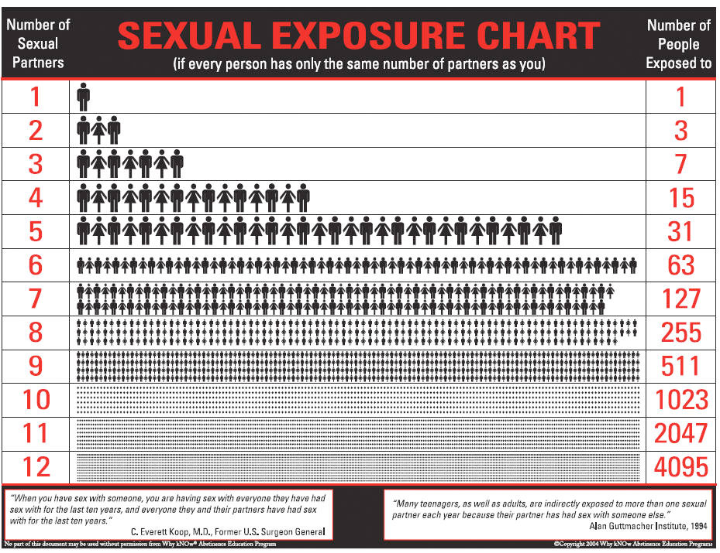

**Learning activities**

1. **Introductory airplane exercise** (5 minutes)

This introductory exercise is designed to be a “grabber,” to get students actively involved in the lesson. It is a simple, brief, participatory activity that illustrates the basic concepts of disease transmission. It works best if students DO NOT know until after the experiment that it has to do with sexually transmitted infections.

**Preparation**: Have 4 paper airplanes numbered one through four ready before class. (Students who arrive early may enjoy making them for you.) Put the following letters on the board: C, H, T, S, G, HP, HB.

The experiment: Tell students they are going to do an experiment with paper airplanes. In order for the experiment to work, everyone must listen carefully to all instructions.

Give paper airplane #1 to Student A and say, “You may decorate this plane and you may fly it anywhere in the room but only you may touch it. So, if you fly it, you have to go get it yourself.”

Paper airplane #2 goes to student B and C. They can fly it back and forth to each other, decorate it, and walk around with it, but again, no one else can touch it.

Paper airplane #3 goes to Student D. S/he can fly it only to Student E but E can fly it to anyone in the room. Everyone in the room who gets it must mark it with a letter from the board before quickly flying it to someone else. In the end, Student E must give the plane back to Student D.

Tell students you will fly paper airplane #4 into the room and anyone may fly it except Students A, B, C, or D. Everyone who gets it must, as quickly as possible, mark it with a letter from the board and fly it to someone else.

Make sure students understand their instructions and have pens or pencils ready. Begin. Students have 2 minutes with the planes.

**Processing the experiment**: When the 2 minutes have passed, process the activity. Tell students that the planes represent their health. The letters on the board and on the planes represent illnesses. Almost all people start out healthy and can make choices that help them stay healthy or increase their chance of getting sick. Ask Students A, B, C, D, and E to tell how they took care of their health and what happened to it during the experiment.

Ask students to indicate by raising their hands how many had contact with planes #3 and #4.

Tell students that with any disease that can be passed from one person to another, there are things we can do to increase or decrease our risk of getting sick. The more we know about an illness, the easier it is to protect ourselves. In this lesson, we will look specifically at sexually transmitted infections-diseases that are spread from one person to another through close sexual contact. The letters on the board represent some of the sexually transmitted infections of greatest concern today: C=Chlamydia, H=Genital Herpes, T=Trichomoniasis, S=Syphilis, G=Gonorrhea, Hp=Human Papilloma Virus, Hp=Herpes, Hb=Hepatitis B.

**II. STI Quiz (15 minutes)**

The STI quiz actively imparts factual information about STI transmission, effects and prevention. Administer the quiz to students. When they have finished, have them self-correct it as you go over the answers, using the questions as a starting point. Additional information is provided in the “Teacher Key.”

**III. Consequences Continuum (10 minutes)**

**This exercise not only helps students increase awareness of possible consequences of an STI, but helps stimulate thinking about their future plans and what they want for themselves. Have eleven sheets of paper ready with the following consequences written on them (one consequence per sheet of paper, written large enough to be seen from across the room.)**

* Infectious to others temporarily
* Painful urination
* Temporary itching
* Miscarriage
* Stillbirth
* Baby born with birth defects
* Death
* Cervical cancer
* Unable to have children
* Herpes sores recur throughout life
* Infectious to others throughout life

Pass out the papers to eleven students and ask them to line up in front of the room (in random order). Tell students that with the variety of STIs that can occur, there is a wide range of possible consequences. Some of the consequences can be very serious. When people’s behavior places them at risk for getting an STI, they have no way of knowing which STI or combination of STIs they may get. This means they are making themselves vulnerable to the entire range of possible diseases and possible consequences. Have the class decide how they would rate the severity of the consequences by having them arrange students with papers in a continuum of risk.

1. Begin by asking students to name what they see as the most serious possible consequence of STIs and ask the person holding that paper to move to the far right of the room.
2. Then ask students to name the least serious consequence and ask the person holding that paper to move to the far left side of the classroom.
3. Arrange other consequences as students see fit between these boundaries. Complete agreement on the arrangement of the continuum is not expected or necessary. Before dismantling the continuum, remind students that the sexual choices we make affect us not only now, but in the future. That is why we care so much about prevention.

**IV. John and Mary role-play (10 minutes)**

The following role-play helps to make the concepts of the lesson less abstract and more real by personalizing the events and placing them within the context of a relationship.

Ask a male student and female student to volunteer to be actors for a short scene. John and Mary are a couple who have been married only a short time when John is sent to New York for a long training session for his job. He and Mary miss each other very much and he calls her every night at 10:00 to say goodnight. One night, he calls and calls and gets no answer. Feeling deserted, he goes to the bar in his hotel and has a few drinks. He meets a young woman in the bar, one thing leads to another, and he has sex with her that night. He feels very guilty about it the next day and doesn’t see her again. Several days after he returns home, he notices an unusual discharge from his penis and when he urinates. The doctor tells him he has gonorrhea and he can be cured with medication. He must also tell Mary he may have given her the infection. The scene starts with Mary greeting John at the door and saying, “Hi, John. How was your day?” Other students in the class can help the actors by supplying lines for them to try.

After a few minutes, stop the scene and discuss what has happened. Ask how it might feel to be in John’s or Mary’s position, how it might have given them an STI and has contributed to the STI epidemic. Ask students how the values of honesty, responsibility, fairness and respect relate to this situation.

**V. Risk-taking /prevention continuum (5 minutes)**

Tell students that the most important thing to understand about STIs relates back to the airplane exercise-that people can protect themselves and help protect others from STIs. Have seven sheets of paper ready with the following behaviors written on them:

* Sex with someone who may have sex with others
* Sex with one person who has sex only with you
* Frequent, chance sex with many unknown partners
* Sex, without a condom, with a questionable partner
* Abstinence
* Sex with more than one person
* Sex with a condom

Give six students one prepared sheet of paper each and ask them to stand in front of the class (in random order) holding their sheets so they can be read by the rest of the class. Precede the same as the consequence continuum. Affirm students’ ability to take good care of themselves and others by making good choices.

**VI. STI Chart**

At this point in the lesson, we created an STI chart with the information provided. You can use this information any way you like, putting together an assessment item, class discussion, peer teaching, etc. This information is the focus of the 2 day lesson. This lesson will be updated at the conclusion of the 08-09 school year.

STI CHART

|  |  |  |
| --- | --- | --- |
| Most Common STI’s | | |
| **Trichomoniasis** | **Human Papilloma Virus** | **Chlamydia** |
| -Caused by a protozoan that infects the urinary tract or vagina.  **Symptoms**  **In Males**:  Painful urination, a clear discharge from the penis, and some itching.  **In Females:**  Itching or burning in the vagina, an unpleasant smelling, yellowish discharge, and pain when urinating.  -Over 7 million people are infected with Trichomoniasis each year. | -Also known as HPV  -**Most Common VIRAL STI.**  **Symptoms**  -Causes no symptoms, so people are unaware that they have contracted it.  -Some forms lead to Genital Warts.  -Can itch or burn.  -Can lead to Cervical Cancer  -Pap Tests can help to  prevent this | -**The most common STI caused by BACTERIA in the USA.**  **Symptoms**  **In Males:**  -Painful, frequent urination  -Colorful discharge from the penis  **In Females:**  -Yellowish, vaginal discharge  -Can lead to PID  -Can be cured by antibiotics.  -Infects nearly 13 million people per year. |

|  |  |  |  |
| --- | --- | --- | --- |
| Other STI’s | | | |
| **Hepatitis** | **Gonorrhea** | **Genital Herpes** | **Syphilis** |
| -Hepatitis B and C  -Infections that attack the liver  -People are often unaware of infection  -**Symptoms**  -Fatigue,  abdominal pain,  nausea, and  jaundice | -Bacterial Infection  -When treated for Chlamydia, also treated for this.  -**Symptoms:**  -Thick pus coming  from penis.  -painful urination  -Can lead to infertility | -Caused by the herpes simplex virus  -One out of every 5 people are infected  -**Symptoms**  -Painful blisters around the mouth or genitals.  -Can be passed from person to person, regardless if there is a blister present. | -Less common than it used to be  -First stage, you get a chance sore  -Second stage, you get sore in mouth and flu-like symptoms  -Third Stage, symptoms disappear but bacteria attacks internal organs.  -Can lead to death. |
| **PUBIC LICE AND SCABIES:**   * Insects and mites that infest in the hair around the genitals * Symptoms include itching around the genitals and a rash. * Can be passed through physical contact, or infested clothing or bedding. * Must use medicated shampoo to treat. | | | |

Avoiding STI's

|  |
| --- |
| **Practice Abstinence** |
| **Avoid Drugs** |
| **Choose Responsible Friends** |
| **Sexual Fidelity in Marriage** |
| **Barrier Protection** |

Seeking Treatment

|  |
| --- |
| Refrain from having sexual activity |
| Inform all sexual partners |
| Seek help from a medical professional immediately |

**VII. Conclusion**

Sexually transmitted infections can have far-reaching and sometimes devastating effects on people’s health and relationships. When making decisions about any kind of intimate sexual contact with others, it is important to think about the behaviors that may put people at risk and the possible consequences of those behaviors. We are not necessarily at the mercy of chance when it comes to sexually transmitted infections; we can make choices that will help us stay healthy.

PID Pubic Lice Gonorrhea

Herpes Syphilis Chlamydia

HPV Chancre Trichomoniasis

Hepatitis

**Sexually Transmitted Infections**

1. ________________________ is an infection caused by a protozoan that infects the urinary tract or vagina.

2. The most common viral STI in the United States is ________________.

3. _______________________ is a disease that causes blisters to form around the mouth and genitals.

4. A _______________________ is a painless sore on the body.

5. _______________________ causes intense itching in the genital region.

6. The most common bacterial STI in the USA is ____________________.

7. ___________________ can be caused if Chlamydia goes untreated.

8. During the last phase of ___________________ organs are invaded which can eventually lead to death.

9. ___________________ can be spread through blood-to-blood contact.

10. If you are treated for Chlamydia, you most likely will also be treated for

________________________________.

List 4 ways to avoid STI’s

1. ___________________________________________
2. ___________________________________________
3. ___________________________________________
4. ___________________________________________

Name the three things you should do if you suspect you have an STI or STD.

1. ________________________________________________________
2. ________________________________________________________
3. ________________________________________________________

Fast forward into the future you are married. One night you make a poor decision and cheat on your partner. A couple of weeks later you begin to experience symptoms of Chlamydia. You see a doctor, and he confirms your suspicion. You must now tell your partner you are being treated for Chlamydia and that there is a chance they have contracted it as well. What do you say? Consider everything that you may need to include in your explanation. (This should be at least 4 sentences)

________________________________________________________________________________________________________________________________________________________________________________________________________________________________________________________________________________________________________________________________________________________________________________________________________________________________________________________________________________________________________________________________________________________________________________________________________________________________________________________________________________________________________________________________________________________________________________________________________________________________________________________________________________________________________________________________________________________________________________________________________________________________________________________________________________________________________________________________________________________________________________________________________________________________________________________________________________________________________________________________________________________________________________________________________________________________________________________________________________________________________________________________________________________________________________________________________________________________________________________________

LESSON 11

**HIV and AIDS**

**TODAY’S GOALS:**

Explain how the HIV infection leads to AIDS.

Describe how HIV is transmitted from person to person.

**National Standards:**

10.1.12 Evaluate factors that impact growth and development

during adulthood and late adulthood. (Relationships)

**MCj02906790000[1]**

INSTANT ACTIVITY

Pass It On!

1. How did you feel before and after the activity? Explain
2. What thoughts were going through your head as you were opening the envelope?
3. How can you avoid feeling this way?
4. How can you tell if someone has HIV?

**Opening Activity:**

**Pass It On! Activity Positive/Negative**

Handout to each student an Envelope that is sealed.

Inside the Envelope is an HIV test sheet that indicates whether you have tested positive or negative.

Prior to opening the envelope, have the students complete the “Shake Hands Activity”.

Make sure that each student writes down (on envelope) who they shake hands with for each of the 3 rounds.

After 3 rounds tell students that their HIV test results are inside of their envelope. Have them do the following on their envelope.

1. How do you feel? Explain

(Before and after finding out the results)

1. What thoughts were going through your head as you were opening the envelope?
2. How can you avoid feeling this way?
3. How can you tell if someone has HIV?

***Develop a web that illustrates who transmitted HIV to others.***

Variation lesson see next page.

**Who me? YES, YOU!**

Standard: Self Management

Core Content: HIV Infection spread

Materials:

* Cup for every student 9 cups need to be numbered prior to class)
* Water
* Diluted Mix of NaOH
* Phenolphalein
* Worksheet

Steps:

* 1. Number all the cups
  2. Fill the cups ½ way with water except one.
  3. Fill one ½ way with the NaOH mixture (be sure to keep a record of which one it is).
  4. Have the students write down the number of people they think they might have sexual relations with over the next 5 years.
     + (What ever number they write on their paper they will need to exchange fluids with.)
     + Have them number their paper with that many spots. Students will need to keep track of their partners number (cup number) with each exchange.
     + They will also roll a die and record that number on their paper with each person they meet. One roll per exchange so both will have the same number.
  5. Students will exchange their fluids by poring all of the fluid of one cup into the other cup and then half back.
  6. Once the students return to their seats place a drop of phenolphalein into each cup. If it turns red they were exposed to HIV.
  7. Have the students track who and when they got HIV from. Can be done as a large group or individual.
  8. Added bonus: The roll of the dice

1. Used a condom and there was no transmission of HIV!
2. Used withdraw NO prevention
3. Used a female condom and No transmission of HIV!
4. No protection used
5. No protection used
6. Abstinence: You are clean no transmission

**Who Me? YES, YOU!**

Cup Number Dice Roll

1. 1.

Reflection questions:

1. Why might teens not use protection?

2. How did you feel when found your test result came out positive?

3. Would you know be more willing to get tested for HIV and have your partner tested before have sexual relations?

VOCABULARY

|  |  |
| --- | --- |
| **HIV** | The Human Immunodeficiency Virus, an incurable sexually transmitted infection that leads to AIDS. |
| **AIDS** | Acquired Immuno Deficiency Syndrome, an often fatal disease of the immune system caused by HIV infection. |
| **Opportunistic Infection** | An infection that attacks a person with a weakened immune system. |
| **Asymptomatic Stage** | The stage of HIV infection in which the infected person shows no symptoms. |

Stages of HIV Infection

**HIV attacks Helper T cells. These helper T cells call other cells to help fight any infection. The HIV cells take over the T cells and destroy them while reproducing.**

|  |  |  |
| --- | --- | --- |
| 1 | Asymptomatic Stage | Soon after exposure to HIV, the infected person may feel flu-like symptoms. They will go away after a weeks. There can be many months or years that follow during at which there will be NO SYMPTOMS. They CAN infect others during this time. |
| 2 | Symptomatic Stage | Symptoms of weight loss, persistent fevers, diarrhea, or fungal infections start to appear. Sometimes cannot appear for 7 to 10 years later. |
| 3 | AIDS | Symptoms become more severe. The body’s ability to fight disease has been weakened by HIV, they are susceptible to infections that a healthy person can easily fight off. One of these infections can lead to death. |

RISKY BEHAVIORS

**There are FOUR main ways that HIV can spread from person-to-person.**

1. Sexual Contact
2. Shared Needles
3. Contact with Blood
4. Mother to Baby

Testing and Treatment

**Testing HIV**

Tests can be done anonymously. If you do test positive for HIV it is important that you contact all previous partners that you have had sex or had shared needles. You should also do follow up testing. People have been given false positive HIV test diagnosis. Even if your results are negative the tests may not register for six months after being infected.

**Treatment**

The main goal of HIV treatment is to keep the person’s immune system functioning as close to normal as possible. (Viral load low, T cell count High)

A combination drug treatment called “triple drug cocktail” has been the most successful method used in recent years. Three different types of drugs have to be taken each day. They are large pills and there is a lot. They also have to be taken at the same exact time every day or they will the no longer work. HIV will adjust and the person will have to start all over with new stronger treatment. The drugs themselves can make you very sick. It is not sure but people have been living longer healthier lives because of this treatment.

MATH and Health

One million people in the United States had HIV infections in the year 2004. Medical costs for a person with HIV may be at least $30,000 per year.

Use this data to estimate the total cost of HIV infections in the United States in 2004.

THEN answer the following question:

With today’s economy, why is HIV prevention such an important issue?

HIV / AIDS Assessment

1. Explain how HIV affects the immune system and how it eventually leads to Aids.
2. What is meant by an Opportunistic infection? Give an Example
3. What are four ways that HIV can be transmitted from an infected person to an uninfected person? List Three ways that HIV is not transmitted.
4. Which region of the world accounts for the majority of HIV infections?
5. Should teens in the United States be concerned about the global Aids problem? Why or Why not?
6. HIV is more common in poorer countries than in wealthier countries. Why do you think this might be the case?